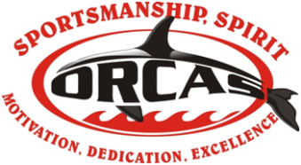 Team Rules, Code of Conduct and Volunteer Requirements
- Each family is committing to volunteer for four (4) assignments during the swim season. Assignments include home meets, away meets, invitationals, championships, and banquet. A sign-up genius will be sent out by the volunteer coordinator once dates/assignments are set. Each family has 2 weeks after the sign-up has been sent out to sign up. If after 2 weeks, a family has not signed up for (4), the volunteer coordinator will assign you to any open positions and notify you of your assignment(s).

- Families are committed to making attendance at meets a priority. Meets are an important part to the swim team experience and help to determine placements at championships. A swimmer must swim at championships in order to receive the end of season trophy. A swimmer must swim in at least 3 dual meets in order to swim at championships.

- Families understand that attendance at practice is also a priority and a direct correlation to performance at swim meets.

- All Orcas strive to be a model of our team pillars: Sportsmanship, Spirit, Motivation, Dedication, and Excellence.

- All Orcas and their families will be extremely respectful of the Girl Scout Property and stay in the gated pool area during practice.

- Speed limit on Girl Scout Property is 5 MPH!!!

- All cars MUST be backed in when parking.

- There is absolutely NO drug, alcohol or tobacco use (to include vaping) allowed on Girl Scout Property.

For more team information, please read our Swim Team 101!

